# TOP CLASS LESSON NOTES TERM I

**LEARNING AREA 2 (ENGLISH)**

**Topics to be covered in term one**

* **Letters**
* **Common words in the environment (vocabulary)**
* **Structures**
* **Preposition**
* **Actions**
* **Colours**

**Learning outcome:**

**Exploring and knowing my immediate environment**

**Competence:**

**A learner cares and values his /her environment.**

**Things found at home.**

**NB: Letters will come first because we can not spell or write without letters.**

**Developing and using my language appropriate**

**Learning outcome 5**

**Competence: A learner writes letters and words.**

**WEEK 1**

**Activity**

**Copy and learn letters**

a b c d e f g h i j k l m n o p q r s t u v w x y z

**Activity 2**

**Write letters a – p**

|  |  |  |  |  |  |  |  |  |  |  |  |  |  |  |  |
| --- | --- | --- | --- | --- | --- | --- | --- | --- | --- | --- | --- | --- | --- | --- | --- |
| a | b | c | d | e | f | g | h | i | j | k | l | m | n | o | P |
|  |  |  |  |  |  |  |  |  |  |  |  |  |  |  |  |

**Activity 3**

**Write letters p-z**

|  |  |  |  |  |  |  |  |  |  |  |
| --- | --- | --- | --- | --- | --- | --- | --- | --- | --- | --- |
| p | q | r | s | t | u | v | w | x | y | z |
|  |  |  |  |  |  |  |  |  |  |  |

**Activity 4**

**Write letters a – z**

|  |  |  |  |  |  |  |  |  |  |  |  |  |
| --- | --- | --- | --- | --- | --- | --- | --- | --- | --- | --- | --- | --- |
| a | b | c | d | e | f | g | h | i | j | k | l | m |
|  |  |  |  |  |  |  |  |  |  |  |  |  |
| n | o | p | q | r | s | t | u | v | w | x | y | z |
|  |  |  |  |  |  |  |  |  |  |  |  |  |

**Activity 5**

**Fill in the missing letter**

a b ------ --------- e f ------- h ------- ------ k l m ---------

------- p ------- r s -------- ---------- --------- w ------- -------- -------

**Activity**

**Fill in the missing letters**

a ------ c d ------- ------- g ----- I j ------ ------- ------- n o

------- q ------- --------- t u v ------- x y ------

**WEEK 2**

**Activity 1**

**Write the next letters**

a ------ b ------- f------ k------- m ----- o -----

**Activity 2**

**Write the next letter**

m------ y----- x------- l------- v------- c--------

**Activity 3**

**Write the letter before**

------ g ----I -----t --------d -----o

**Activity 4**

**Write the letter before**

-----w ------z ------e -------m -------r -------u

**Activity 5**

**Listen and write letters**

Teacher’s choice. Pick letters you want the learners to write.

**WEEK 3**

**Things found at home (vocabulary)**

**Activity 1**

**Read and draw**

|  |  |  |
| --- | --- | --- |
| table | chair | Radio |
| stool | mat | Door |

**Activity 2**

**Read and draw**

|  |  |  |  |
| --- | --- | --- | --- |
| window | plate | fan | flower |
| basket | glass | dish | Spoon |

**Activity 3**

**Read and draw**

|  |  |  |  |
| --- | --- | --- | --- |
| mingling stick | water | jerrycan | Kettle |
| jug | knife | mug | Tray |

**Activity 4**

**Name the pictures.**

|  |  |  |
| --- | --- | --- |
|  |  |  |
|  |  |  |
|  |  |  |
|  |  |  |

**Activity 5**

**Name the pictures.**

|  |  |  |
| --- | --- | --- |
|  |  |  |
|  |  |  |
|  |  |  |
|  |  |  |

**WEEK 4**

**Fill in the missing letter**

k-----ttle b-----tlle tr------y ch-----r fl-----wer

mingling st----ck sp---- ------n r-----dio.

**Activity 2**

**Fill in the missing letter**

gl----ss m----t p-----t cl-----th Kn-----fe b----sket

**Activity 3**

**Read and draw**

|  |  |  |
| --- | --- | --- |
| This is a basket | This is a knife. | This is a television |
| This is a jerrycan | This is a cup. |

**Activity 4**

|  |  |  |
| --- | --- | --- |
| That is a flower | That is a table. | That is a glass. |
| That is a plate. | That is a bed. | That is a door. |

**Activity 5**

**Complete the sentences**

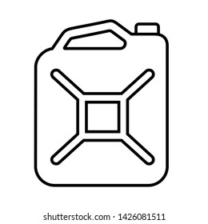Here is a ______________ 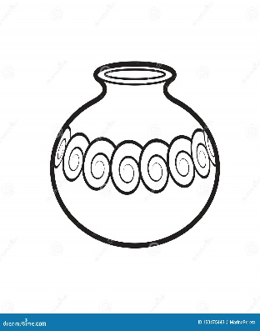Here is a______________

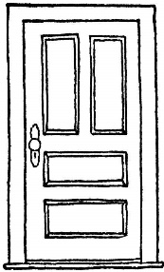Here is a______________ 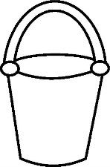Here is a___________________ 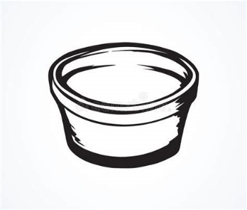Here is a______________

**WEEK 6**

**THINGS IN THE CLASSROOM**

chalk marker chalkboard ruler pen pencil book rubber

duster bag tin box bench desk chair drum leaf

**Activities**

Naming

Read and draw

Tick underline or circle for a picture

Complete the sentences

Fill in the missing words.

Make sentences

**WEEK 7**

**Things I play with**

drum water leaf grass tin mat toy doll wall box

**Note:** same activities.

**WEEK 8**

**PREPOSITION**

**Activity 1**

**Use in, on**

   

**Activity 2**

**Use in, on, over, under**

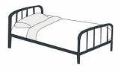 _______  _______ _______

______

**Activity 3**

**Use over , under**

 

**Activity 4**

**Tick the correct word**

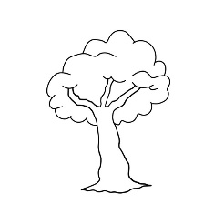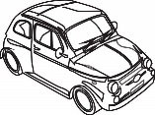 near under

 in on

over on

**Activity 5**

**Match correctly**

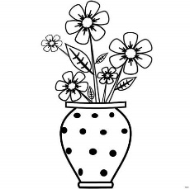 over

 near

 in

 on